What is a Machine Learning Model? 

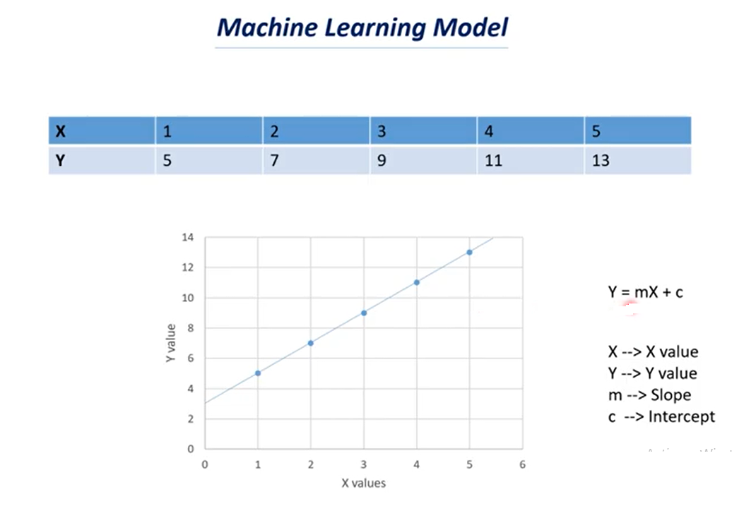

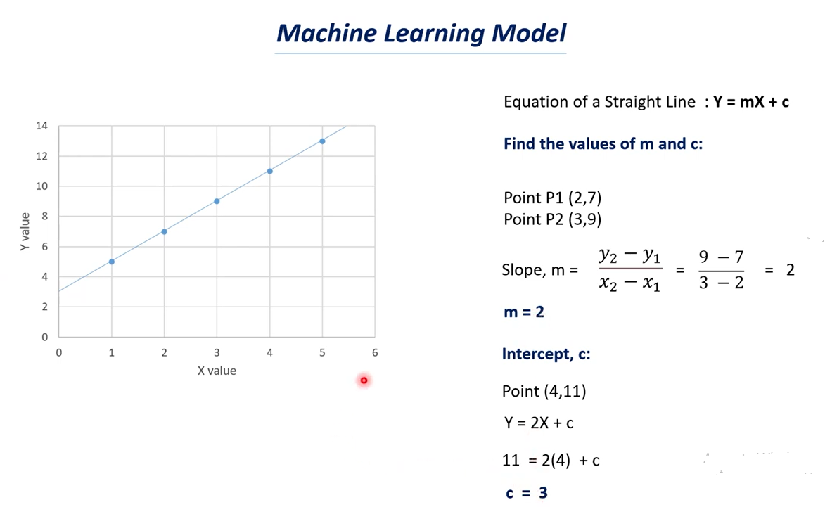

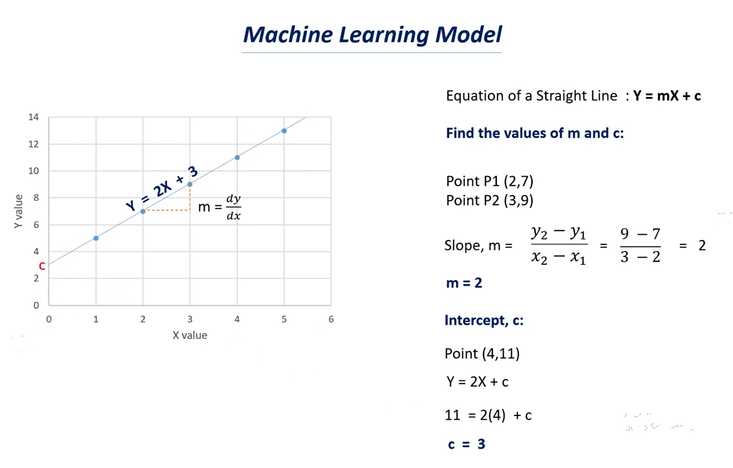

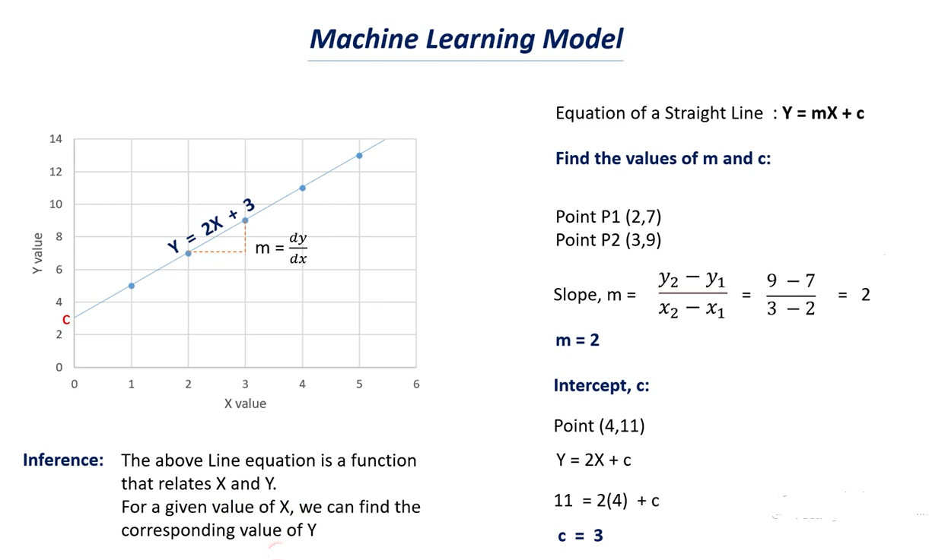

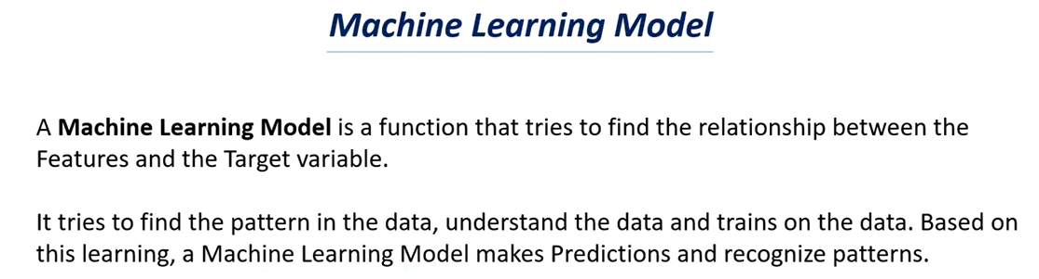

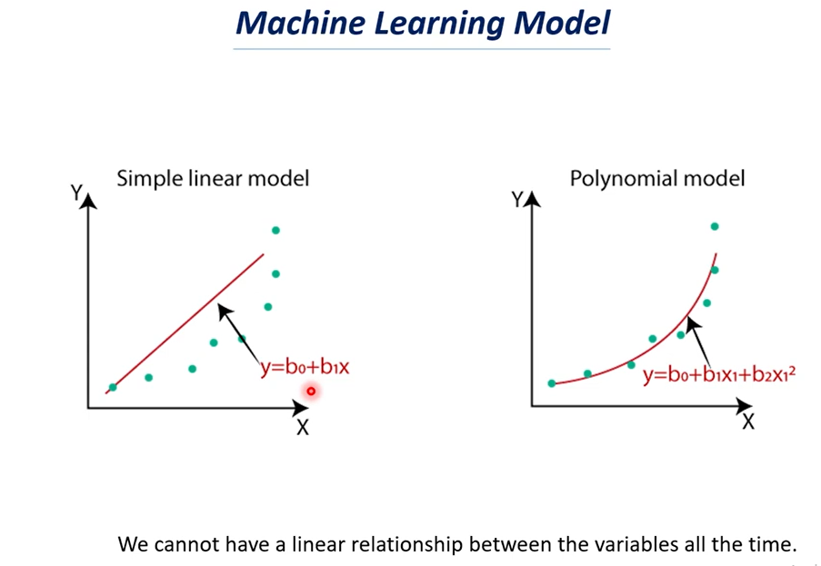

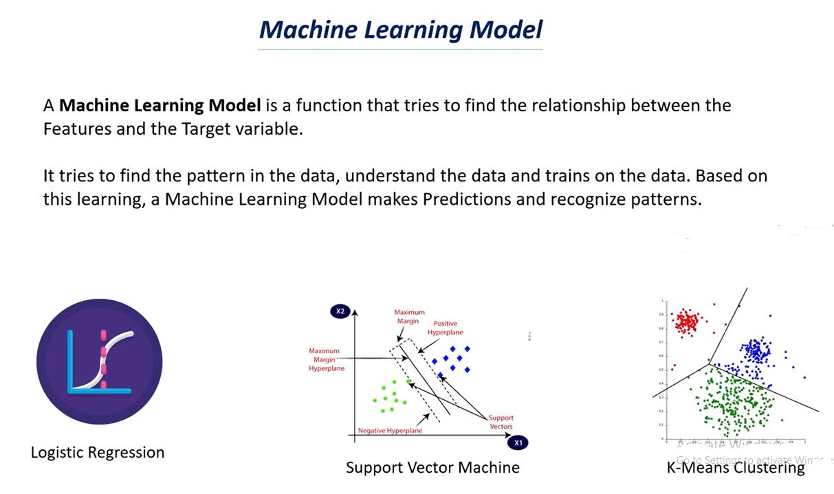

# Supervised Learning Models | Supervised Learning

# 

# 

# 

# 

# Unsupervised Learning Models | Unsupervised Learning

# 

# 

# 

# 

# 

# How to choose the right Machine Learning Model ,Model Selection ,Cross Validation

# 

# 

# 

# 

# 

# 

# 

# 

# Over fitting in Machine Learning:

# The Model over trained on the training data points.

# We have X values and Y Values and we have these many datapoints.

# We try to fit the curve to these data points.

# It is an optimal Model.

# It will try to find the common trends in it,

# If the model is over fitted we will get a curve something like this above.

# Here the curve try’s to join all the data points.

# In first case it is the regular curve.

# In second case the curve try’s to join all the data points.

# The over fit model try’s to model the data too well which means it tries to fit to all the data points, Here we can’t have a regular curve.

# Note: when we don’t get a regular curve we can’t make a good prediction out of it.

# In case of optimal model we have generalized curve or generalized mode.

# In case of over fit model we don’t have a generalized curve as we observed we have rises and dips in the curve

# If you see the data points in both the graphs are same but curves are different i.e over trained of the data.

# In case of over fit when a model learns the details and noise in the training dataset.

# Noises can be outliers and some data points that don’t make sense.

# Note: The good model try’s to ignore these noises that are presents in the dataset.

# In case of optimal it tries to find a generalized value.

# In case of over fit it tries to pick all the data points which can be noise.

# Sign that the model has over fit:

# The accuracy on the training data will be very high and the accuracy on the test data will be very low.

# That why we try to find the accuracy score for both training data and test data as well.

# If the accuracy of training data & test data is the same let’s say accuracy of the training data is 85% and the accuracy of the test data is 83% its almost similar.

# In this case we can say the model is optimal.

# Suppose the accuracy of the training data is 95% and the accuracy of the test data is 30% or 40% then we say that the model is over fitted.

# When the model tries to fit to all the data points it can’t give generalization and it can’t be reliable to make prediction out of it.

# 

# 

# 

# As we have discuss less data causes over fitting and if we have large dataset then the model ignores the outliers most of the time.

# It can understand the data better if it have more data so it is very important concept in machine learning and deep learning as well.

# More the data better the performance of the model is.

# If you have more data than the chances of over fitting is very less.

# Reduce the number of layers in the neural network as we discuss increase of layers in the neural network that causes over fitting so we need to reduce the number of layers.

# Early stopping: Early stopping is a technique that is used in machine learning what happened in machine learning is that in machine learning we iterate the data multiple times so the model tries to learn from the data multiple times this is called as iteration because it does the same thing again and again.

# So when we do early stopping technique the model tries to stop learning once it is over fitted.

# If over fit start it stop the training part this is called early.

# Bias – Variance tradeoff it is the most important topic in machine learning .

# Bias-variance tradeoff is used to find the optimal model for a dataset.

# This is used for a model optimization technique.

# Dropouts: if we have dropouts some neurons will be dropout randomly and some neurons will be turned on randomly and this stop the problem of over fitting.

# As we have less neuron the complexity of the model reduced.

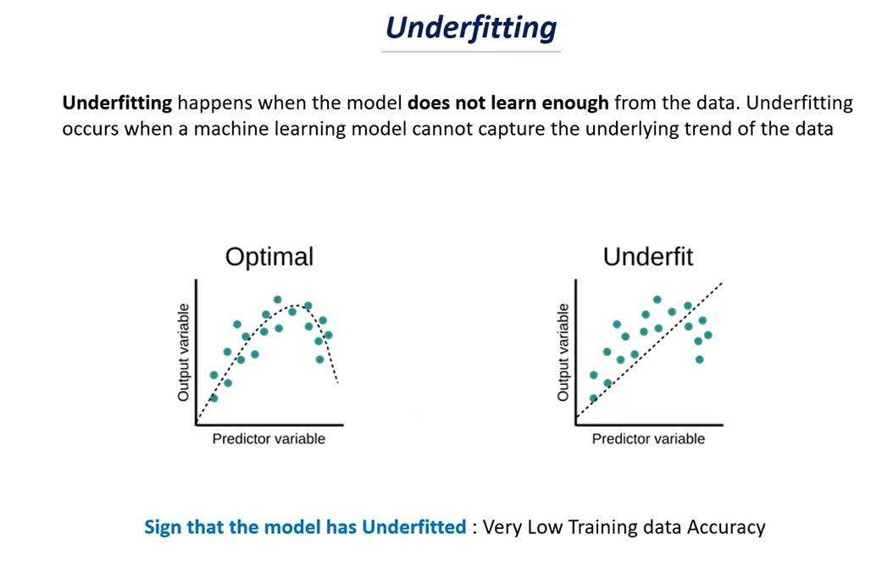

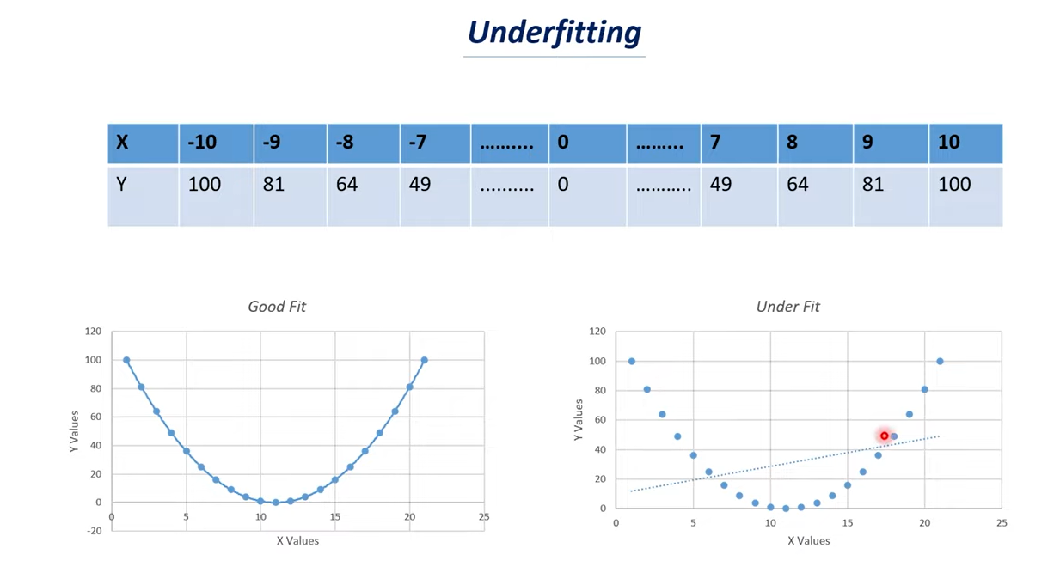

* y value depends on the value of x.
* If you see the graph it represents the parabola if you join all the data points.
* It tries to fit the data in a line but it is impossible to fit all these data points in a linear line.
* We can’t get a proper fit because it is a parabolic relationship but the model tries to fit in a simple line.
* Here the model fails to find the trends present in the dataset and it can’t fit all the data points in the curve.
* Whereas good fit tries to fit all the data points in a curve and it can find a trend.
* If we observed the values first decreases for a certain values of x and y increases if the value of x increases.

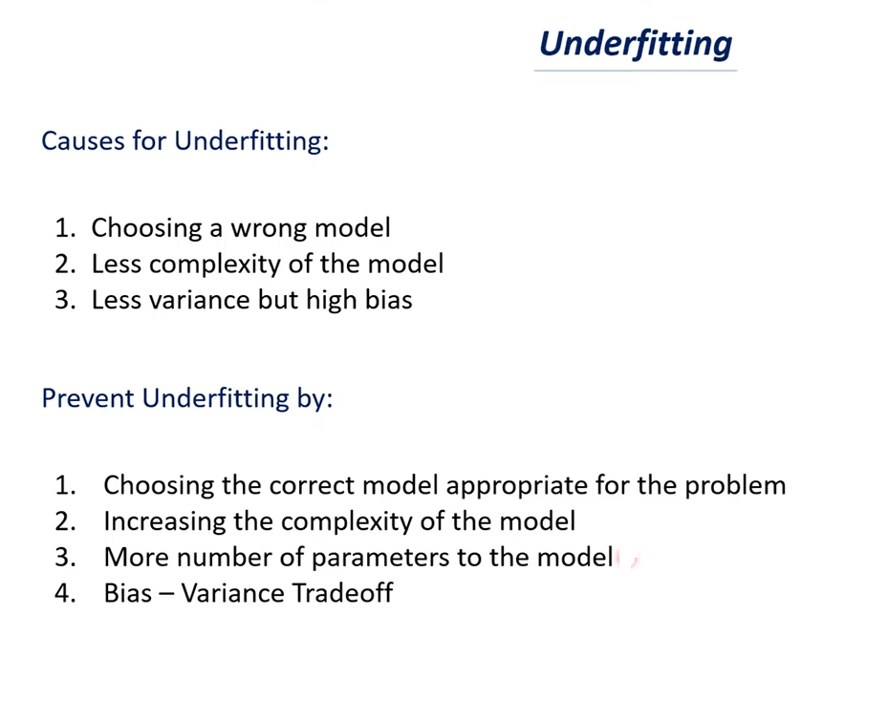

**Causes of Under fitting:**

* Choosing a **wrong model** - So in the previous case we have to choose a parabola model and if we have choose a linear model it can’t fit this particular data.
* So choosing a correct model is very important.
* If you choose a wrong model that will be one of the cause of under fitting.
* Having a less complex model is another example of under fitting.
* When you compare the parabola and linear model. Linear model is a very simple model whereas parabola is more complex model compare to parabola.
* Complexity of parabola is more comparing to a line.
* If you have very less complex model then there is a problem of under fitting.
* **Less Variance but high bias:**
* Bias variance Tradeoff is something that deals with to find the optimal model for our dataset.
* For this we need to understand the variance and bias.
* Bias is nothing but approximation that our model make for a target function so in machine learning we have features and targets.
* In machine learning model is something that finds the function that relates the features and target.
* Here features are nothing but x values and the target is nothing but y values.
* Bias is nothing but approximation function.
* Variance is how your model changes or how your function changes if you use different training data.
* If you have less variance and high bias values you will have the issue of under fitting.

This are the few important issues faced in machine learning model.

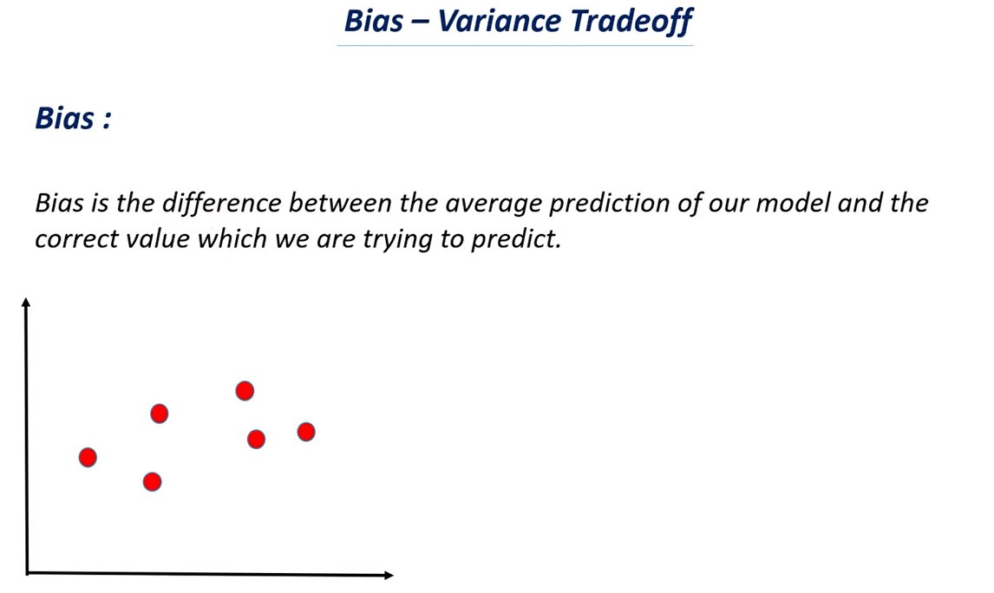

* Before going to Bias – Variance Tradeoff let’s understand Bias.
* This is the formal definition of Bias above.
* Let’s say we are making machine learning model to predict the salary of a person given on their experience.
* Here we are using experience data and we feed this to a machine learning model and let’s say the model has predicted that person earns a salary of about 28000 rupees per month.
* So in this case the value predicted by our model is 28000 rupees and the current value or actual value is 30000.
* So the difference between the two values is 2000 rupees and the difference between the predicted value and correct value is called as Bias.
* Let’s say that the first data point represent one year of experience which is on x axis and the corresponding value on y-axis is 20,000.
* Similarly we have several data points and we need to find the model in order to fit the particular data.
* If you look at the data we can say there is a linear relationship between them.
* And there is a positive correlation between them i.e. if one value increases the other value also increases i.e. the number of years of experience of a person increases there salary also increases.
* So when you have such kind of relationship between x-axis and y-axis or x- values and y-values we can fit the data by using normal straight line.
* This line signifies that if you take any particular point let’s say it represent 10 years of experience and if you take the corresponding values 80,000 rs.
* This is how we try to understand the data and the model which we are fitting this is a straight line which means there is a linear relationship between them when one value increases the other value also increases.
* Now it is impossible to draw a straight line which touches all these data points **so we try to build our model that close to all these data points.**
* **Note**: it is impossible for this particular model to touch all this data points so you can’t use straight line for that you need to use curve.
* Straight line can’t touch all the data points.

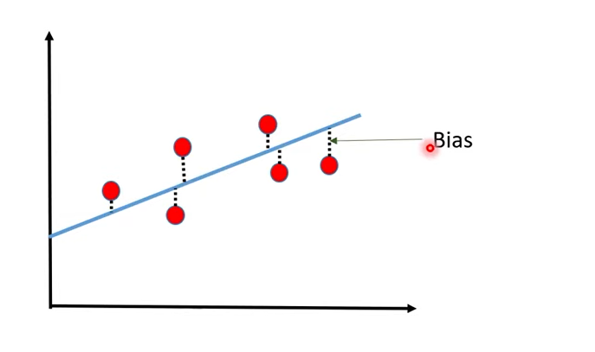

* The distance between there data points and the model is Bias.
* The blue color line is called the model which is an example of linear model or linear regression and we know the equation of the line is y=mx+c i.e. this equation of that particular line.
* We try to find the distance between data points and the model is called as Bias.

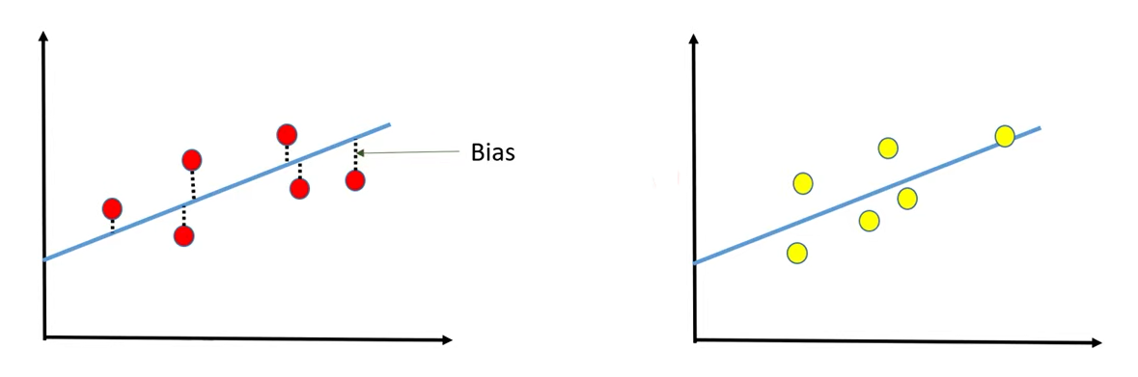

* In case we have some set of training data and now we are changing the training data.
* So this is one set of data and another set of data.
* Both these lines are different with respect to slope and intercept because we are using different kind of data but they are almost similar to each other.
* There is huge bias in both cases.
* So there is bias the distance between data points and the model in both the cases.
* But there is not much variation to the model because these two model are very similar to each other so there is a very less variation between them we called these variation as variance.
* In this particular case as we can see very high Bias and very low variance that is the influence which we are getting.

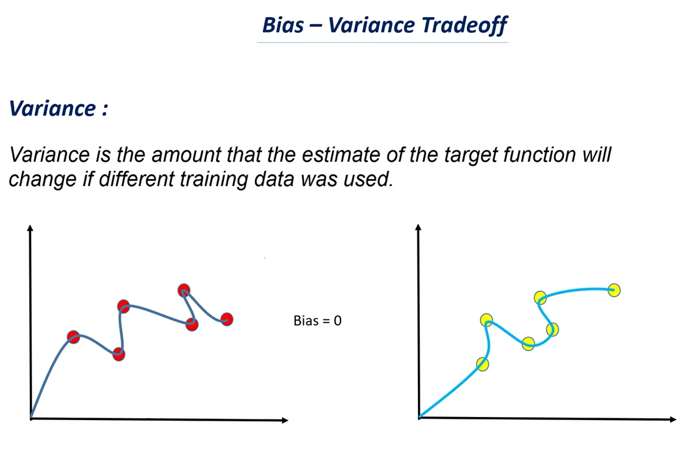

* If the change is huge we called this particular case as high variance.
* In this case there is a zero bias as it touches all the data points and there is no distance between the data points and the model.
* When you use similar kind of model as straight line most of the cases you will have a very high bias but there wouldn’t be any much variance in it.
* When we use more complex model the bias will be zero but there will be huge variance in it.

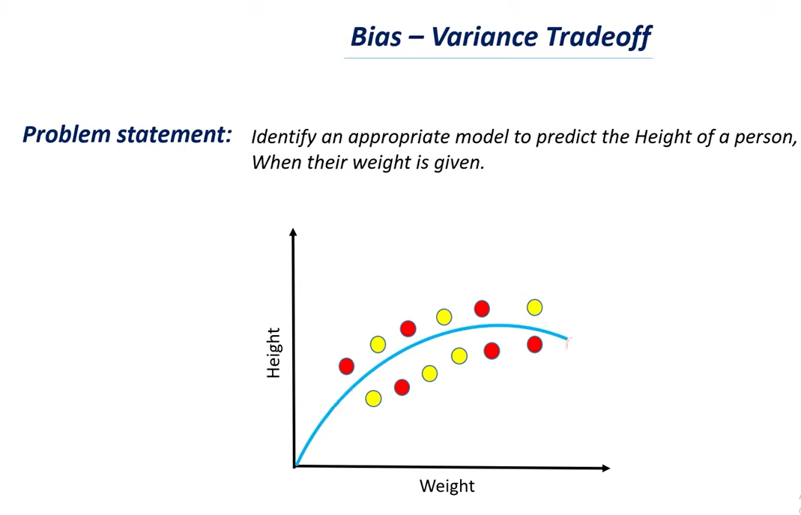

* We have a problem to identify an appropriate model to predict the height of a person when there weight is given.
* We need to analyzes this and we need to find weather we need a simple linear model or we need a more complex curve.
* Let’s say we have this data, weight in the x-axis and height in the y-axis and these are all the data points we have.
* If you want to fit optimized curve to this particular data we will get a curve as above.

